WEBSITE DEVELOPMENT PROJECT  
FINAL REPORT 

### PREPARED FOR

CSE326- Final Assignment

Assigned by- Amandeep Kaur

### PREPARED BY

Mohit Pal Singh (11902185)

Priyanshu Dash (11902193)

Satyam Dwivedi (11902199)

DESCRIPTION

The Food Company is a grocery website.

The aim of this website is to provide fresh grocery at competitive prices at the ease of you sitting on your couch.

It has the following modules-

1. Home Page
2. Revolution
3. Products
4. Advantages
5. Contact Us

HOME PAGE:

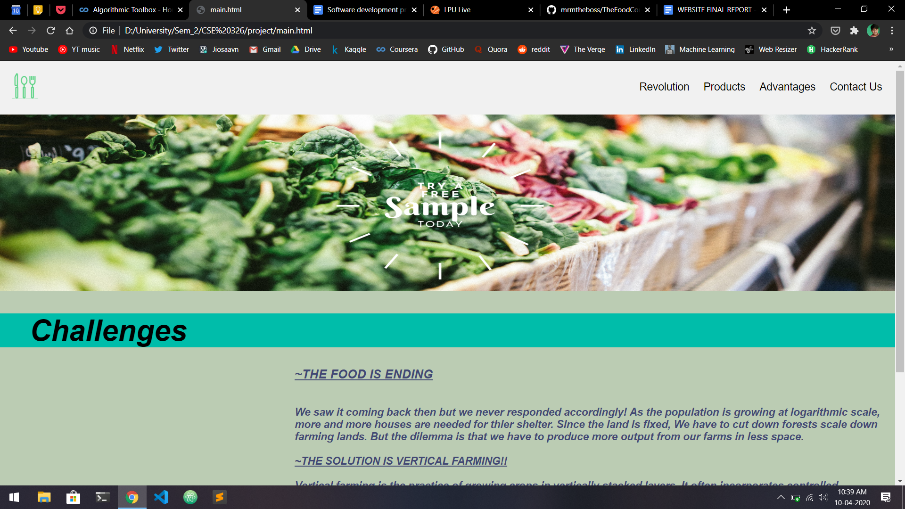

At the top,

We can find the Navigation bar containing our Logo on the left followed by the modules of our website i.e. Revolution, Products, Advantages and Contact Us.

Coming down, We can see a beautiful banner which is used as a marketing strategy to attract new customers by giving a free sample.

Later to that, We have provided the current challenge i.e the ending of the food.

After its elaboration,

We have gone thoroughly with the solution i.e Vertical Farming i.e.

***Vertical farming is the practice of growing crops in vertically stacked layers. It often incorporates controlled-environment agriculture, which aims to optimize plant growth, and soilless farming techniques such as hydroponics, aquaponics, and aeroponics. The main advantage of utilizing vertical farming technologies is the increased crop yield that comes with a smaller unit area of land requirement. The increased ability to cultivate a larger variety of crops at once because crops do not share the same plots of land while growing is another sought-after advantage. Additionally, crops are resistant to weather disruptions because of their placement indoors, meaning less crops lost to extreme or unexpected weather occurrences. Lastly, because of its limited land usage, vertical farming is less disruptive to the native plants and animals, leading to further conservation of the local flora and fauna.***

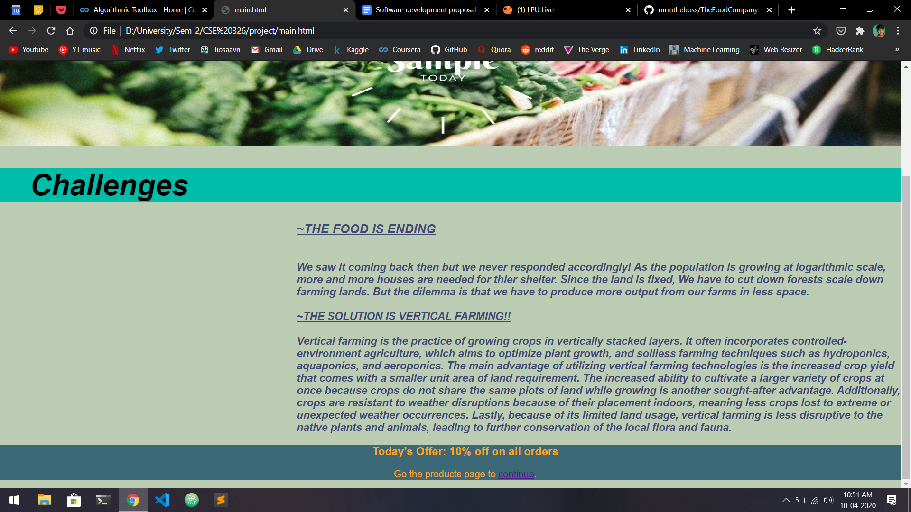

At the very last,

We have a given footer containing ‘TODAY’S OFFER’.

REVOLUTION:

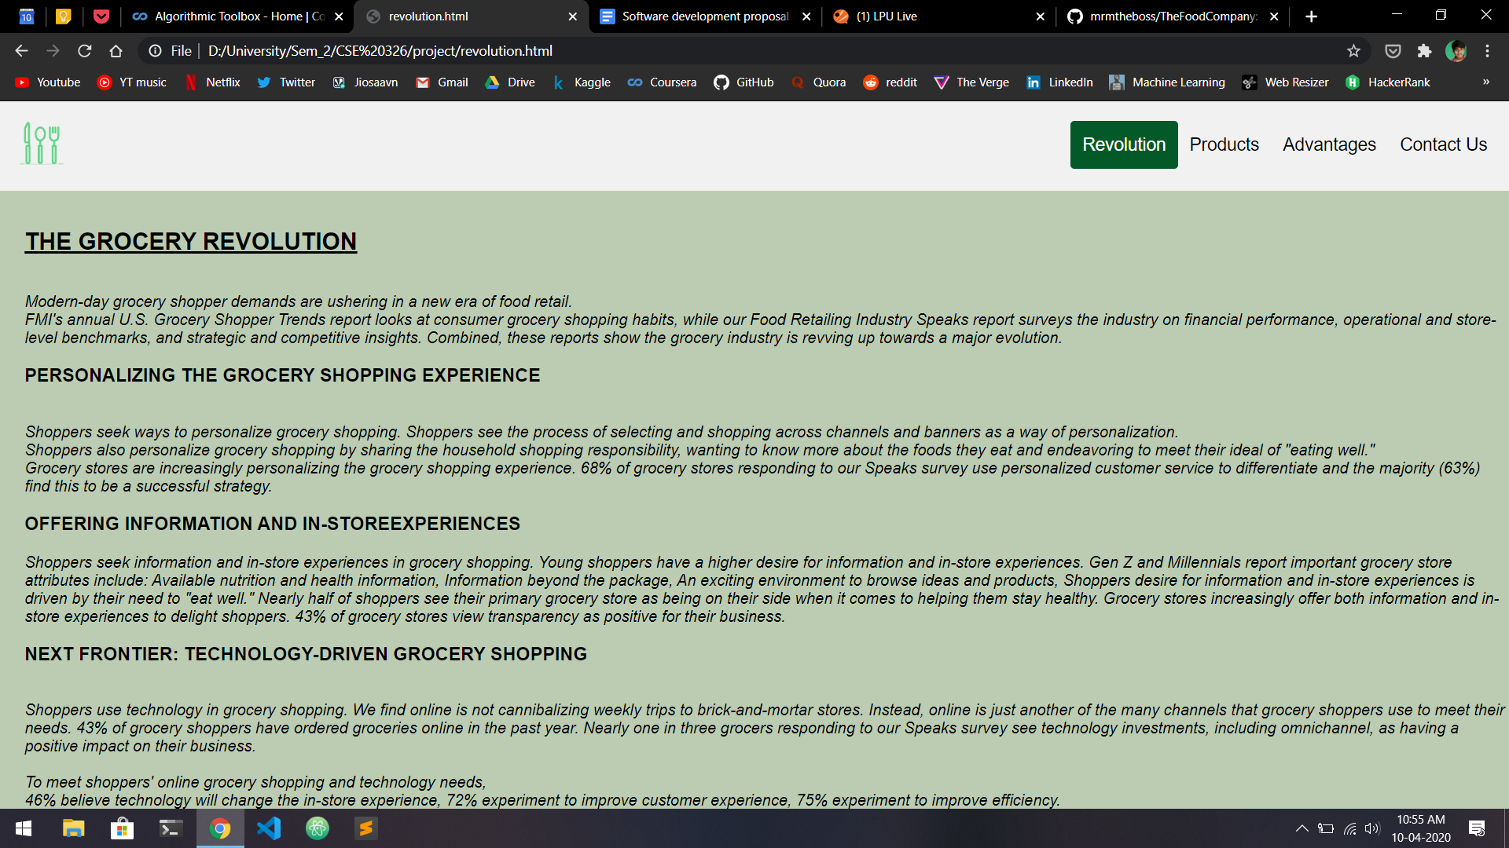

At the top, It's the same navigation bar and as we are the revolution page,

The Revolution page is highlighted.

It contains the revolution which grocery websites began as they become common in regular households.

Some of the titles are:

### PERSONALIZING THE GROCERY SHOPPING EXPERIENCE

*-Shoppers seek ways to personalize grocery shopping. Shoppers see the process of selecting and shopping across channels and banners as a way of personalization.*

*Shoppers also personalize grocery shopping by sharing the household shopping responsibility, wanting to know more about the foods they eat and endeavoring to meet their ideal of "eating well."*

### OFFERING INFORMATION AND IN-STOREEXPERIENCES

*Shoppers seek information and in-store experiences in grocery shopping. Young shoppers have a higher desire for information and in-store experiences. Gen Z and Millennials report important grocery store attributes include: Available nutrition and health information, Information beyond the package, An exciting environment to browse ideas and products, Shoppers desire for information and in-store experiences is driven by their need to "eat well."*

### NEXT FRONTIER: TECHNOLOGY-DRIVEN GROCERY SHOPPING

*Shoppers use technology in grocery shopping. We find online is not cannibalizing weekly trips to brick-and-mortar stores. Instead, online is just another of the many channels that grocery shoppers use to meet their needs. 43% of grocery shoppers have ordered groceries online in the past year. Nearly one in three grocers responding to our Speaks survey see technology investments, including omnichannel, as having a positive impact on their business.*

PRODUCTS:

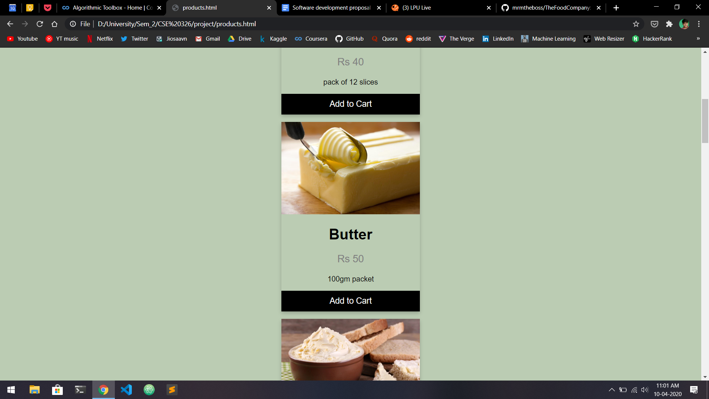

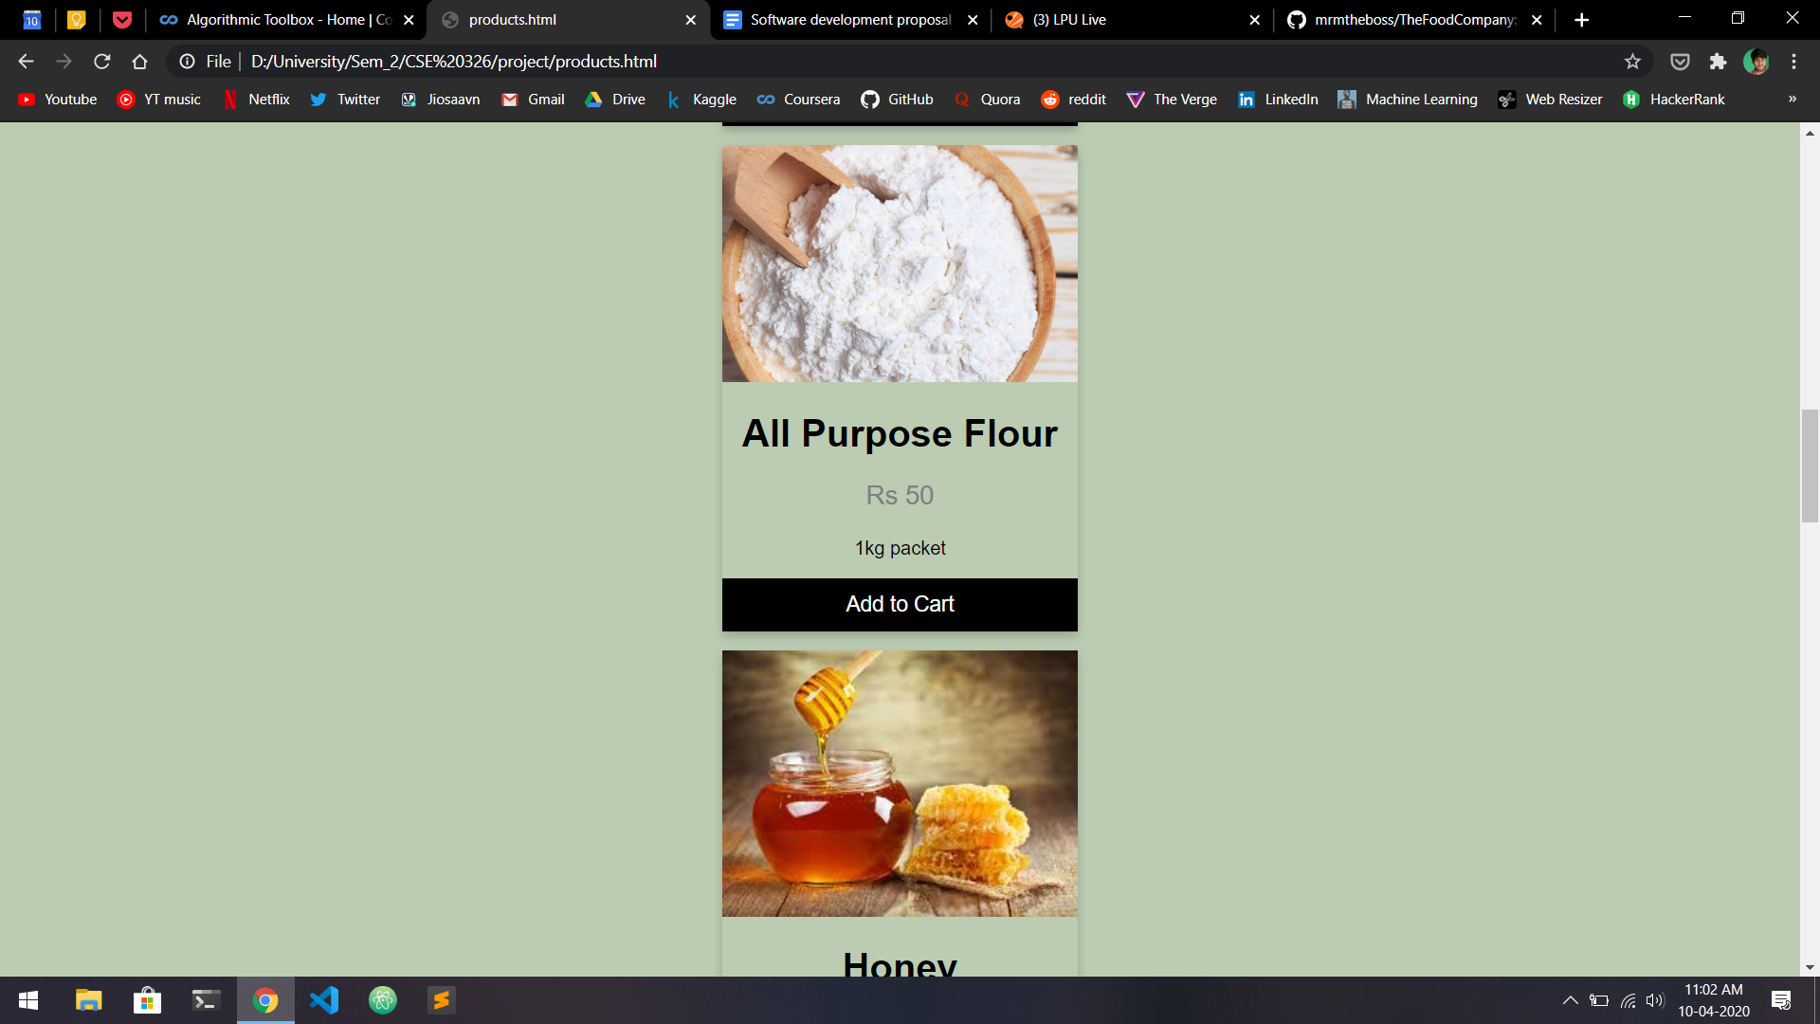

In this module, We have provided the grocery catalogue which includes:

1.Pack of Vegetables

2.Bread

3.Butter

4.Cheese

5.All Purpose Flour

6.Honey

7.Onion

8.Pasta

9.Rice

10.Salt

11.Sugar

12. Tomatoes

Along with the prices on the respective cards, we have also provided a short description about the product’s packaging and a “add to cart” button.

ADVANTAGES:

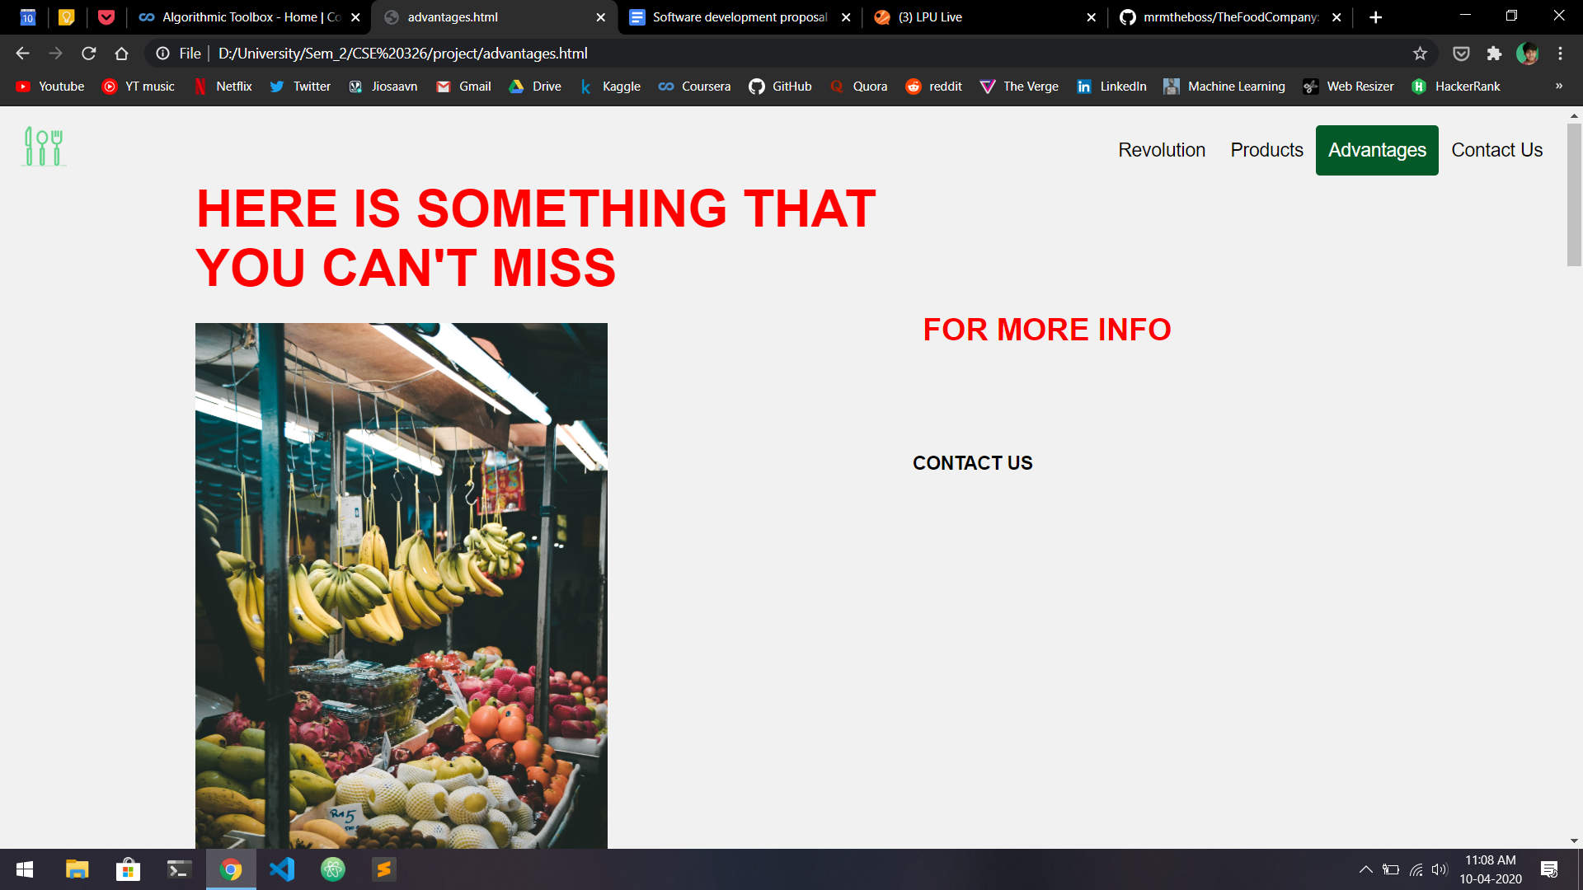

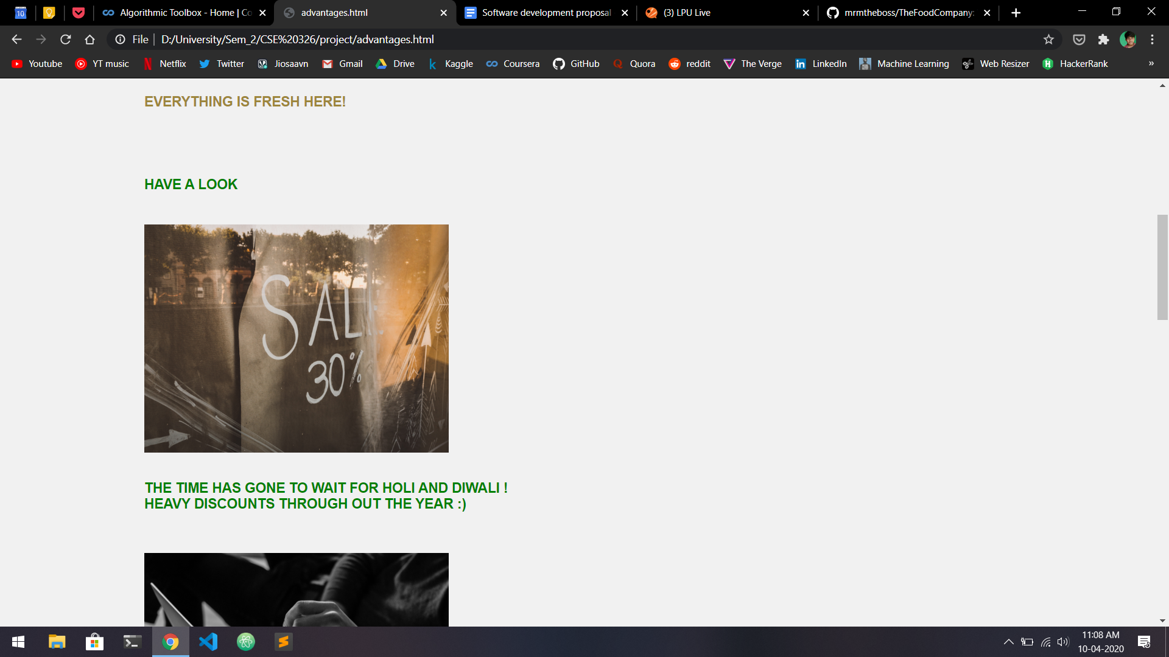

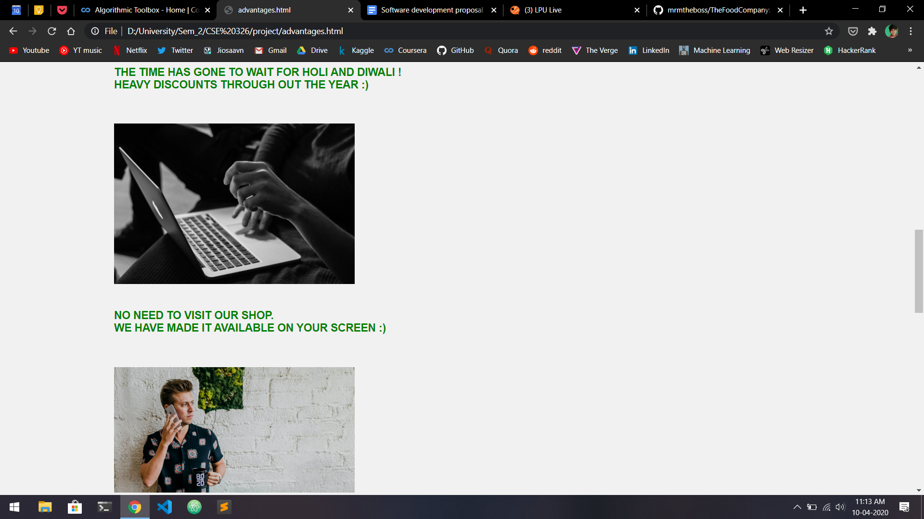

Here, We have listed some of the advantages users will get by using our service which are:

1. THE TIME HAS GONE TO WAIT FOR HOLI AND DIWALI !HEAVY DISCOUNTS THROUGHOUT THE YEAR :)
2. NO NEED TO VISIT OUR SHOP.WE HAVE MADE IT AVAILABLE ON YOUR SCREEN :)
3. DON'T WORRY ABOUT YOUR PRODUCTS THEY WILL REACH AT YOUR DOOR STEPS SAFELY :)
4. 100% GUARANTEE ON PRODUCT QUALITY ELSE REFUND IS OUR RESPONSIBILITY :)
5. WE ARE VERY SERIOUS ABOUT YOUR HEALTH WE ONLY SELL FRESH AND HYGIENIC FOOD :)
6. ARE YOU A CHOCOLATE FAN

IMPORTED CHOCOLATES AND COFFEE FROM THE EDGE OF THE WORLD :)

We have also given a link in a separate division on the right side which will take the user directly to the contact page.

CONTACT US:

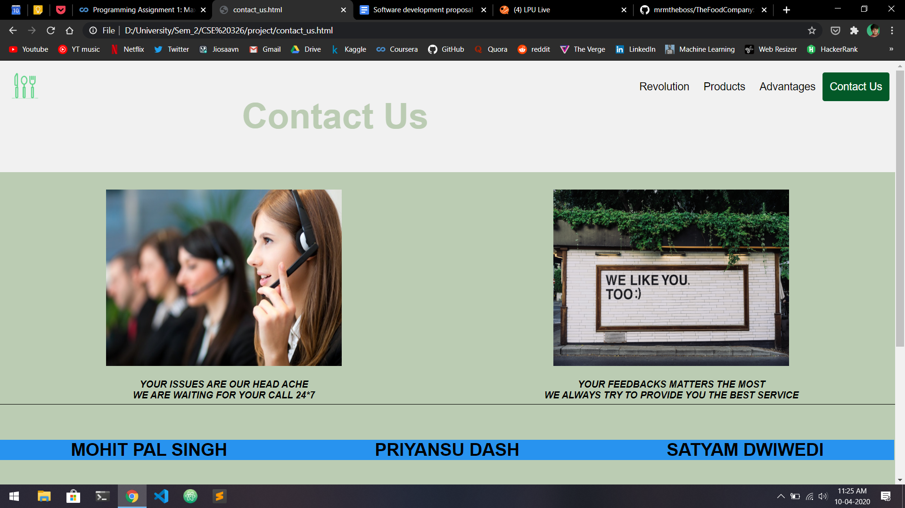

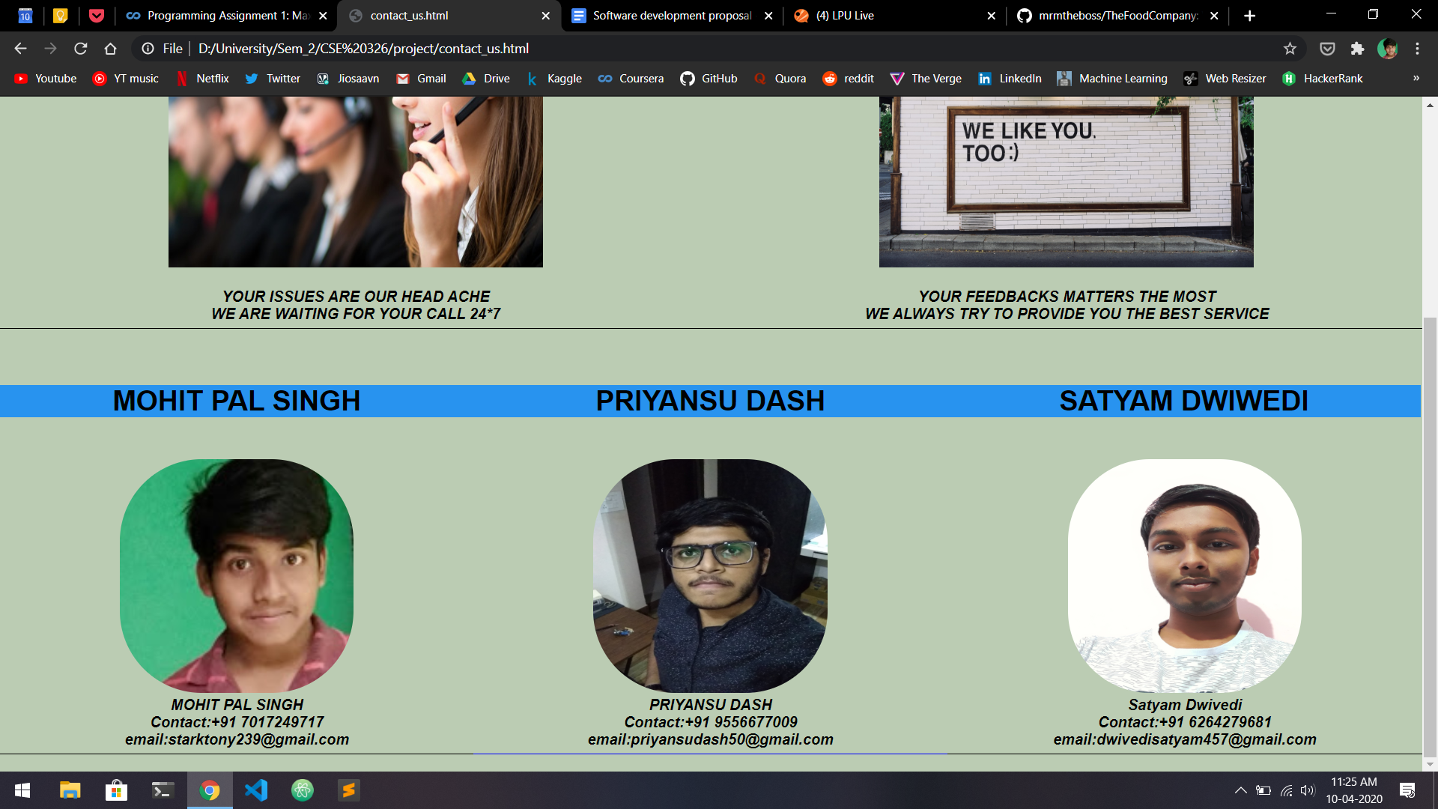

Here, We have two pictures denoting our key features i.e.

-24*7 support and

-Customer satisfaction is our top priority.

Then after a Horizontal break,

We have put together all the ways one can use to connect to any of the members of the group along with the respective display pictures below their pictures for easy identification.

The details mentioned are:

1. Name
2. Phone No.
3. Email.

GANTT CHART

GANTT VIEW-

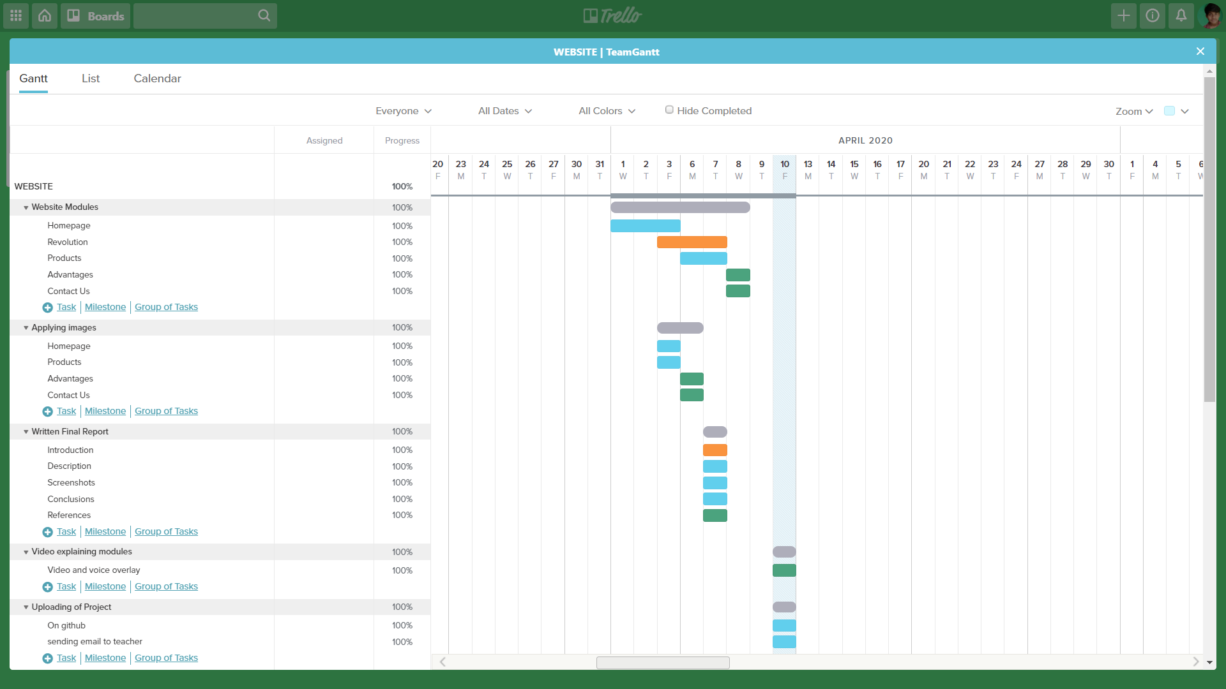

CALENDAR VIEW-

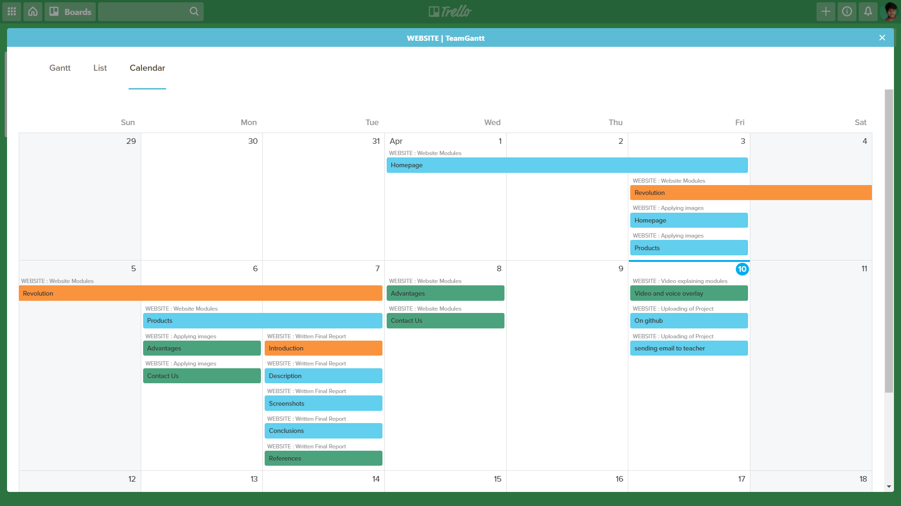

CONCLUSION

Within the making of this assignment(website),

We have learned about various Web development technologies and practised them well on this project. Some of them are-

1. HTML 5
2. CSS
3. CSS Flexbox
4. Forms
5. Responsive design
6. Color palette

And we are Very Thankful to our teacher Amandeep Kaur mam for guiding us well and allowing us to make mistakes so that we can learn more.

WE HAVE LEARNT ALOT!!!!

REFERENCES

1. [www.w3school.com](http://www.w3school.com)
2. [www.geeksforgeeks.com](http://www.geeksforgeeks.com)
3. [www.wikipedia.com](http://www.wikipedia.com)
4. [www.adobe.com](http://www.adobe.com) ( For color palette )
5. [www.trello.com](http://www.trello.com) ( For Gantt Chart )
6. [www.google.com](http://www.google.com) ( For pictures )
7. Our Class Notes
8. www.docs.google.com ( For final report)
9. [www.youtube.com](http://www.youtube.com) (For final Video )
10. [www.github.com](http://www.github.com) (For the project management )
11. [www.gmail.com](http://www.gmail.com) (For mailing )